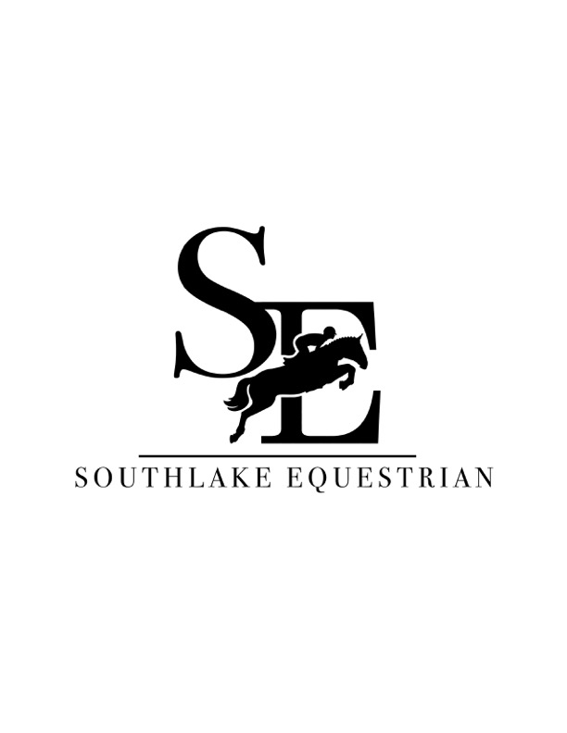
Social Media Waiver

Please check all that apply

______ I give permission to post photos of my minor child on all Southlake Equestrian social media platforms.

______ I give permission to post photos of my horse on all Southlake Equestrian social media platforms.

______ I do NOT give permission to post photos of my minor child on all Southlake Equestrian social media platforms.

______ I do NOT give permission to post photos of my horse on all Southlake Equestrian social media platforms.

______________________________________ ____________________________
Signature Date

______________________________________
Please print name

